Multivariate Analysis of Variance (MANOVA)

TUI University

DEL18 – Quantitative Research and Advanced Statistics II

Dr. Wenling Li

MULTIPLE REGRESSION

SLP 4

Deborah K. Hicks

June 8, 2009

Introduction
This report pertains to 624 children between the ages of 3-19 who participated in a childhood respiratory disease study (CRD) in East Boston. The dataset report contains six variables. The first part of the data analysis allows FEV as the dependent variable seeking to identify IVs as having an influence in FEV. The next phase of analysis requires the research to determine a find out the association between FEV and age, sex, height, and current smoking status. Current smoking status is used as the DV.
The independent variables are height, age, smoke status and gender. The purpose of this data analysis is to answer the research question that seeks to determine the relationship between FEV (forced expiratory volume in liters), height, age, sex, and smoking status. The researcher first checked assumptions. Then the researcher ran multiple regression, rather than logistic regression to determine the relationship between dependent variable FEV and covariates sex, age, height, and current smoking status. Current smoking status was used as the dependent variable.

Assumption Checking
Table 1
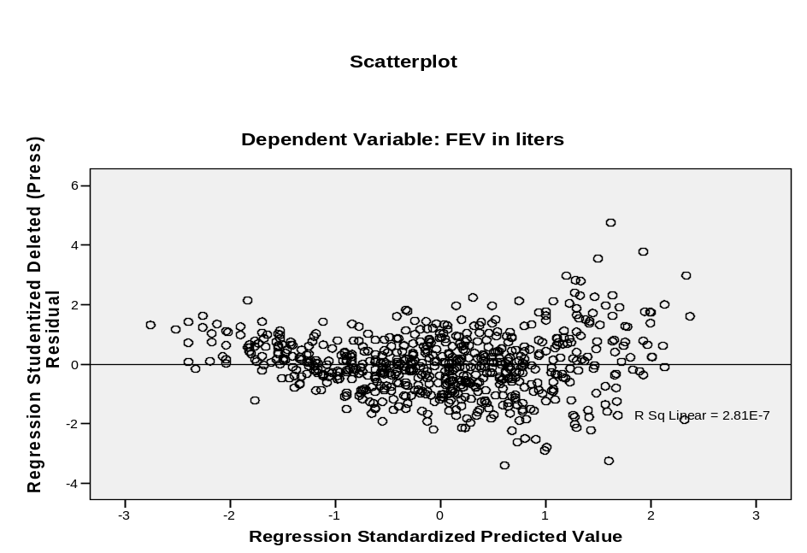

There is a pattern of the points and are not randomly distributed through the scatter plot.
Table 2
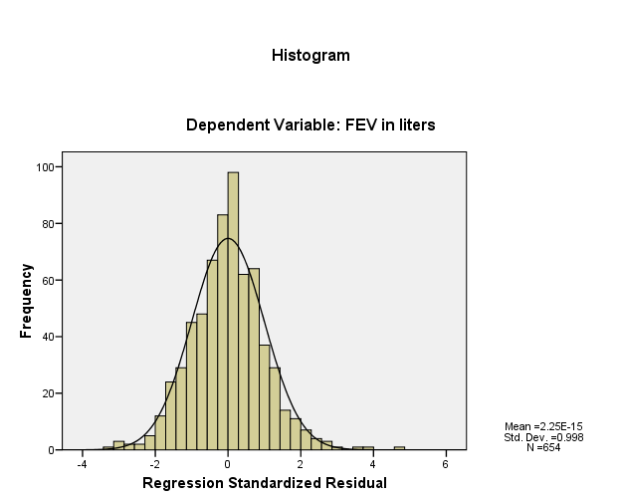

The residuals are distributed: 2.25E-15 normally.
Table 3
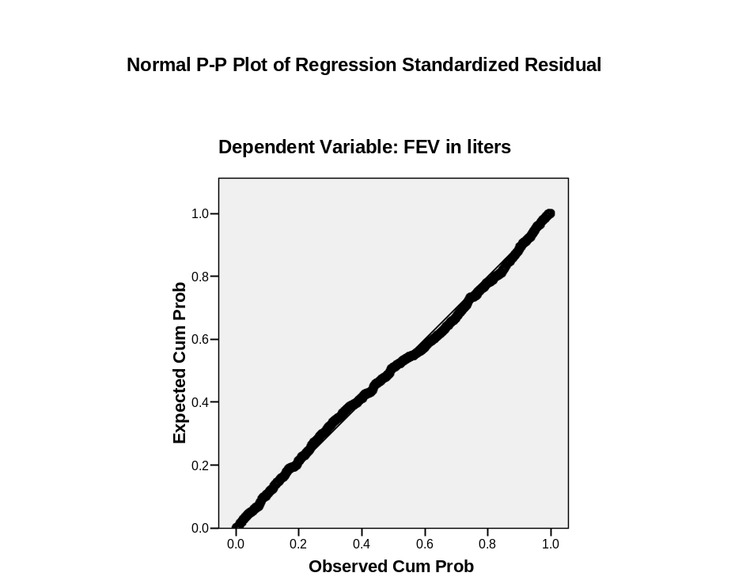
Normality assumptions: The residuals are distributed 2.25E-15 normally.
Multiple Regression
Table 4
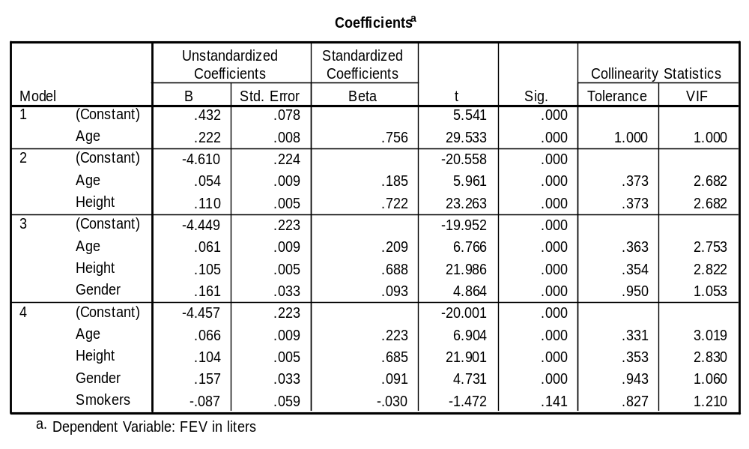
Reference- Model 4:
The collinearity is not present among these independent variables. Tolerance (<.01), VIF (<=10).

Multiple Regression
Table5: Method: Entry
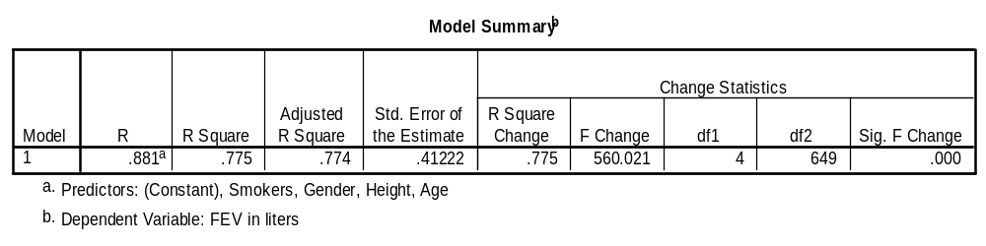
The model accounts for 77.4% of variance.

Table 6: Method – Entry
Anova
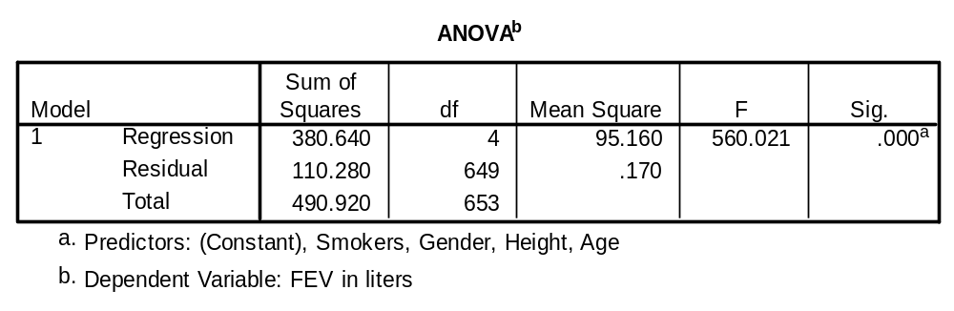
F(4,649)=560.02, p=.000; p<,01
Model 1 is significant.

Table 7: Entry
Coefficients
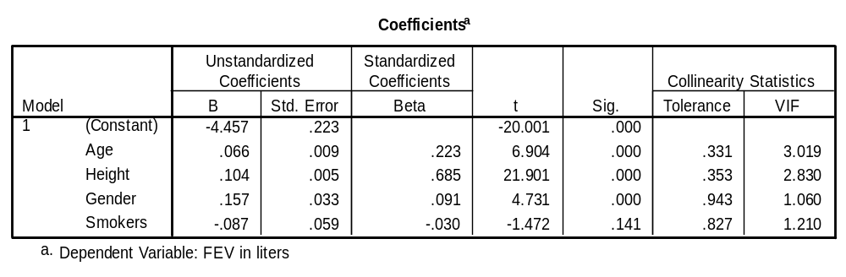
Age, height, and gender are significant predictors.
FEV= -4.457+.066(A)+.104(H)+.157(G/S)+ -.087(S)
Smokers shows no significance with FEV
Standardized Coefficients
Age = β = .223, t = 6.904, p<,01
Height = β = .685, t= 21.091, p<.01
Gender/Sex = β = .091, t- 4.731, p<.01
Smoke β = .-.030, t+-1.472, p>,05
Table 8 : Stepwise
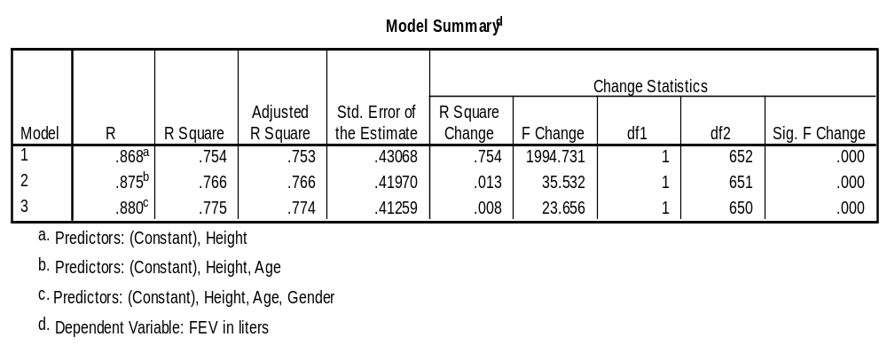
For height (Model 1) accounts for 75.3% of the variance.
The inclusion of Height, Age, and Gender (Model 3) account for 77.4% of the variance.

Table 9: Stepwise
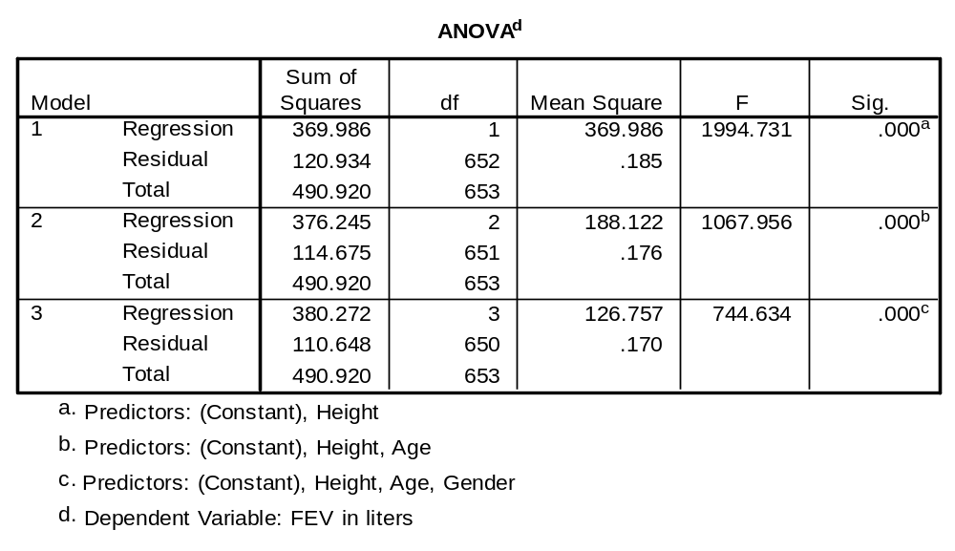
Note: Model 3 indicates F(3,650) =744.634, p=.000, p<.01
This model is significant.
Table 10: Coefficients
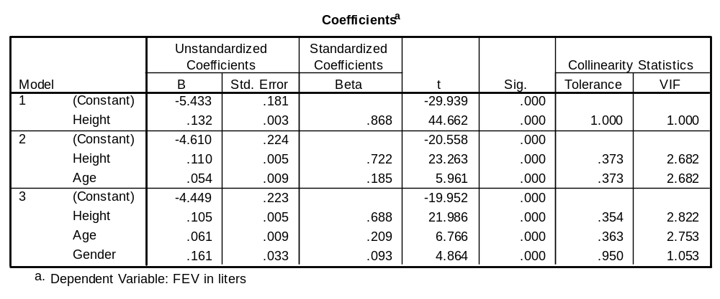
Standardized Coefficients: Height contributes to strongest IV, followed by age.
Model 3
FEV = -4.449+.105(H)+.061(A)+.161(G/S)
Height (b=.688, p<.01) contributed strongest to the DV, following are age and gender.
Table 11: Hierarchical
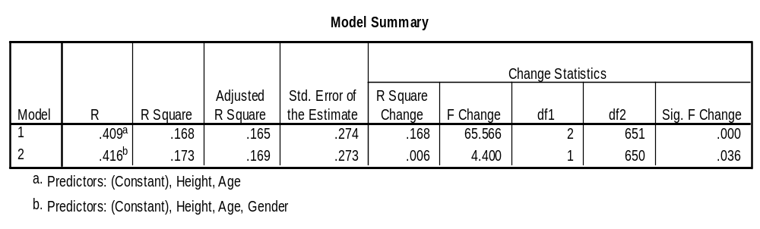
In Model 1 height and age accounts for 16.5% of the variance. For Model 2, the inclusion of height, age, and gender account for 16.9% of the variance.

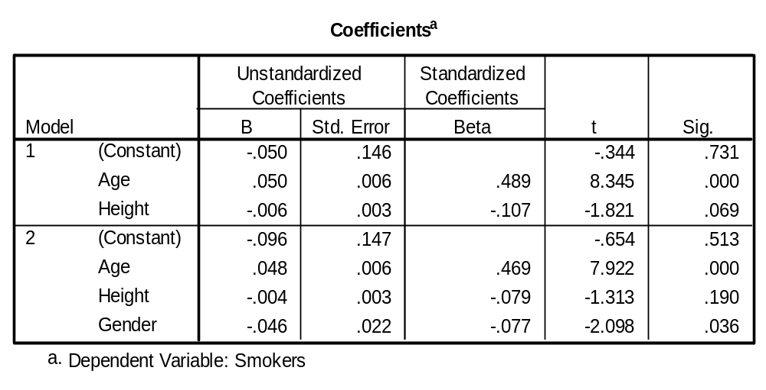
Table 12

Age is a significant predictor.
FEV = -.096-.004H₊.048A-.046

